**Practice – EDA Visualisation**

**Visualisations in Databricks**

**%sql**

USE CATALOG samples;

SELECT

   hour(tpep_dropoff_datetime) as dropoff_hour,

   COUNT(*) AS num

FROM samples.nyctaxi.trips

WHERE pickup_zip IN ('10001', '10002')

GROUP BY 1;

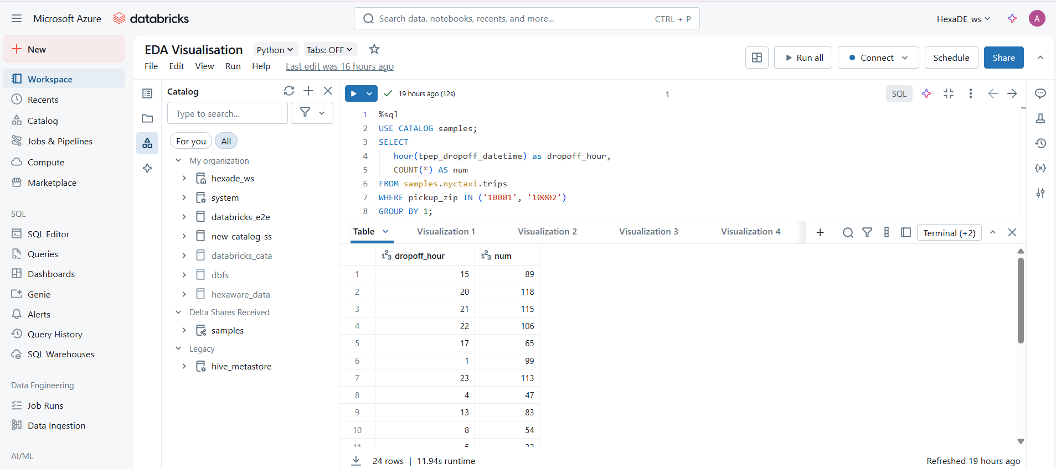

**Visualisations Types**

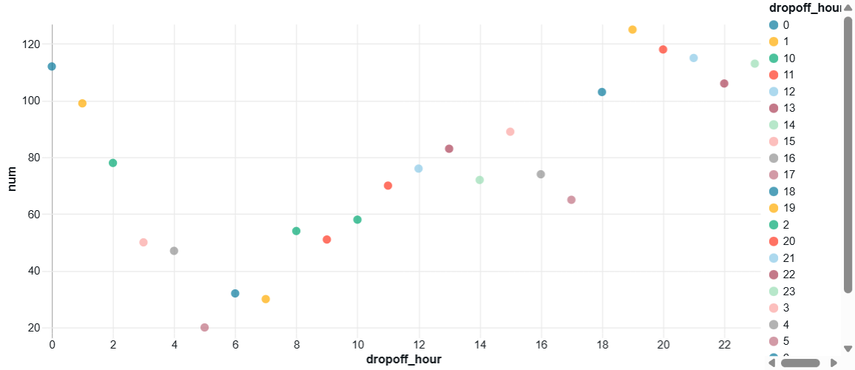

**Scatter**

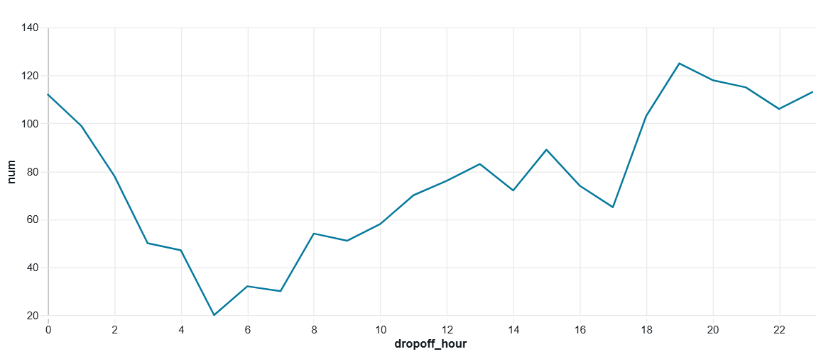

**Line**

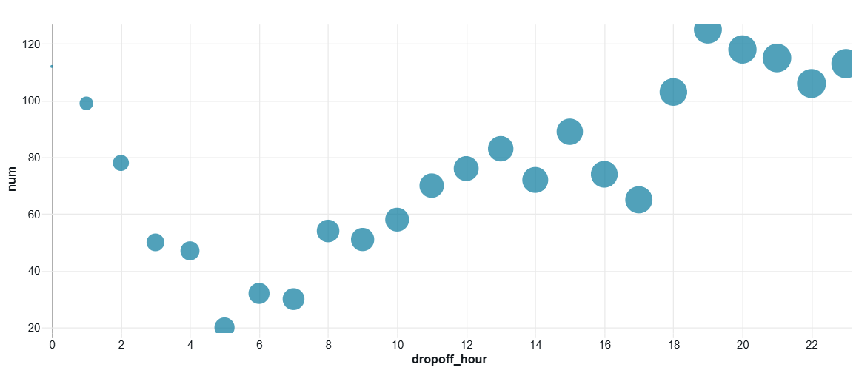

**Bubble**

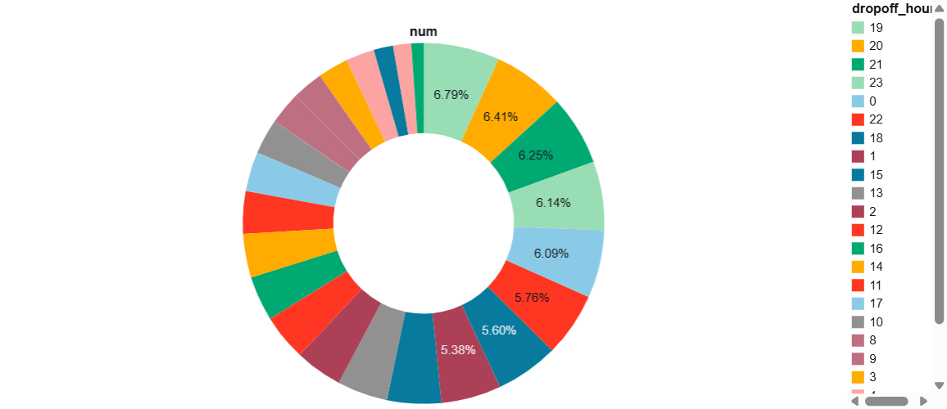

**Pie**

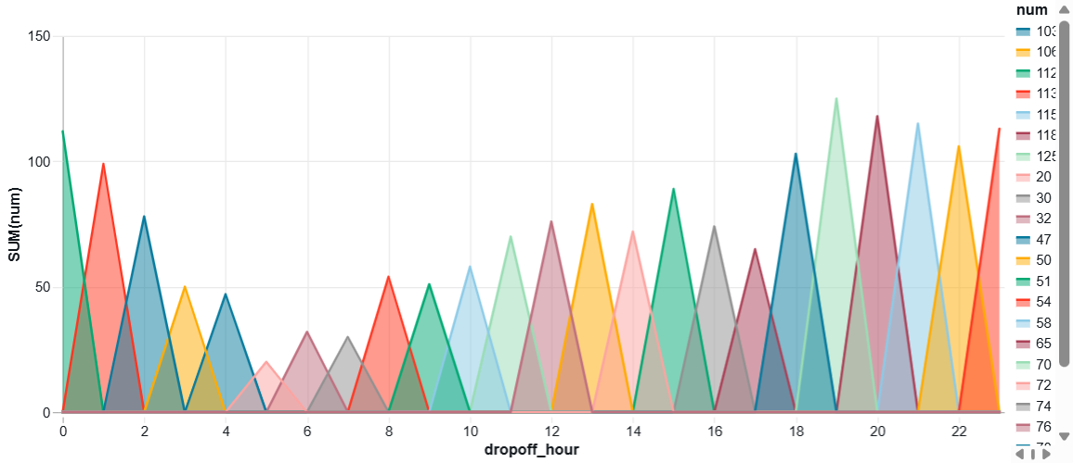

**Area**

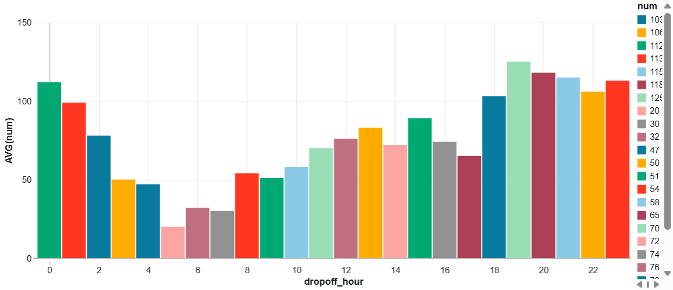

**Bar**

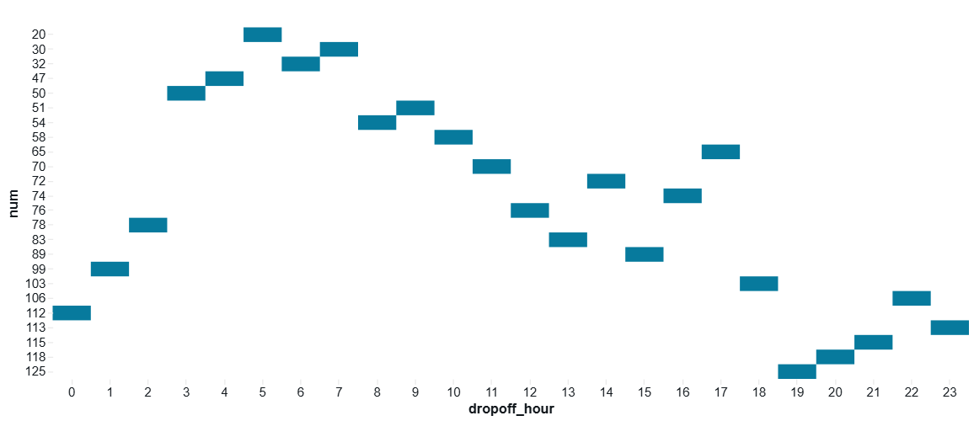

**Heatmap**

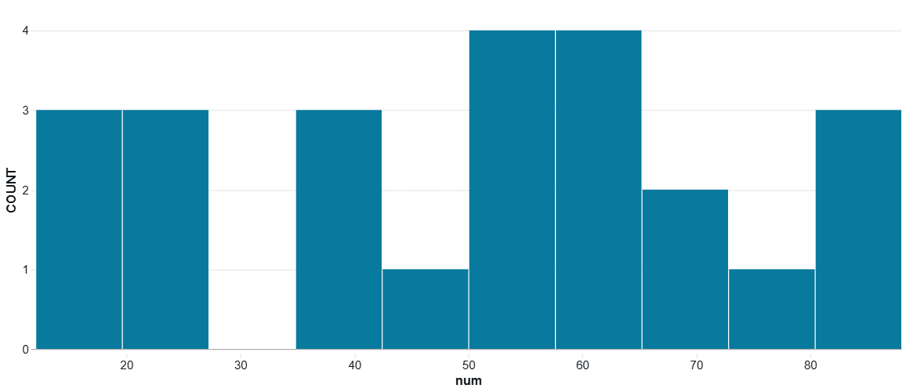

**Histogram**

**%Python**

from pyspark.sql.functions import hour, col

pickupzip = '10001'  # Example value for pickupzip

df = spark.table("samples.nyctaxi.trips")

result_df = df.filter(col("pickup_zip") == pickupzip) \

              .groupBy(hour(col("tpep_dropoff_datetime")).alias("dropoff_hour")) \

              .count() \

              .withColumnRenamed("count", "num")

display(result_df)

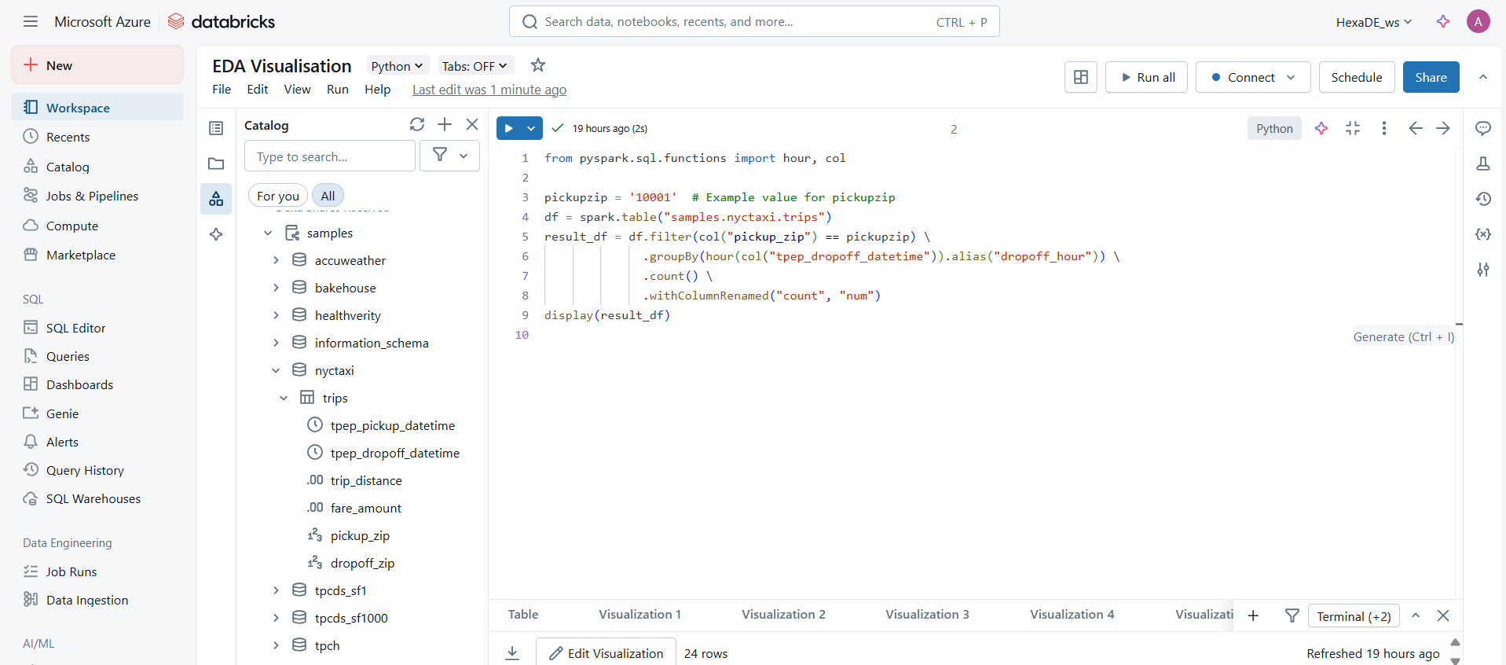

**Visualisations Types**

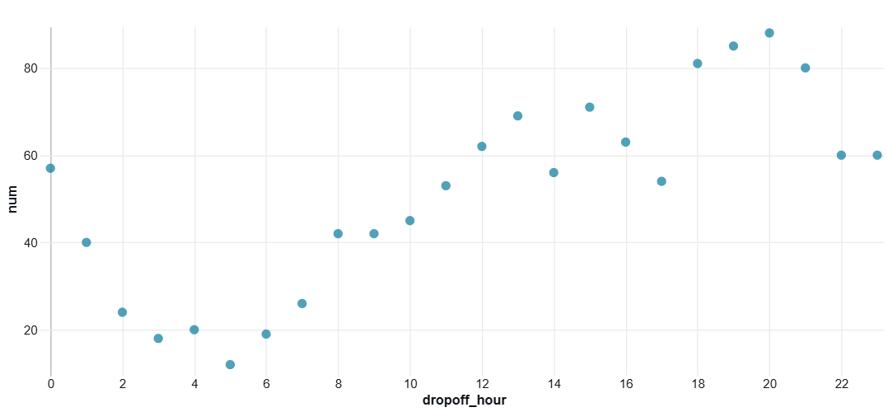

**Scatter**

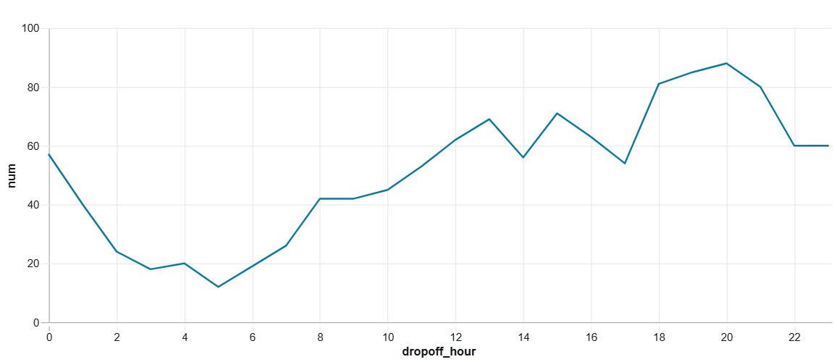

**Line**

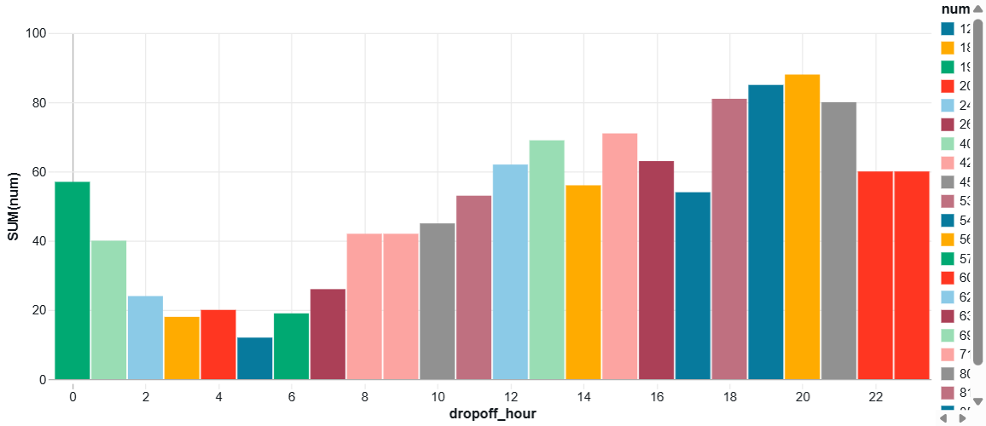

**Bar**

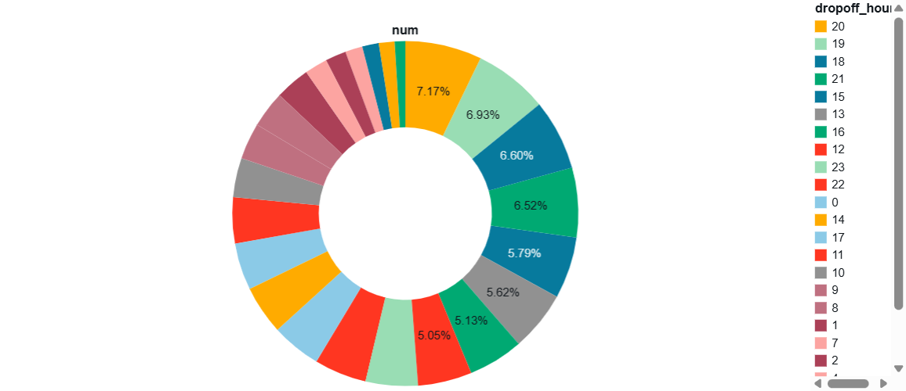

**Pie**

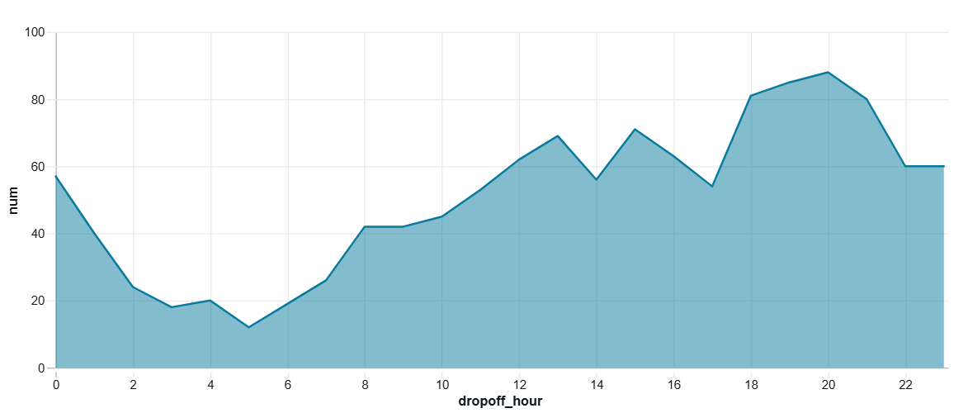

**Area**

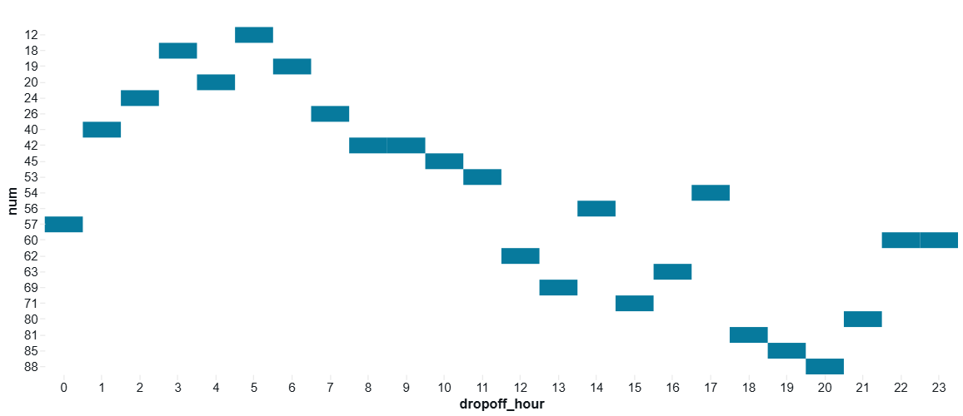

**Heatmap**

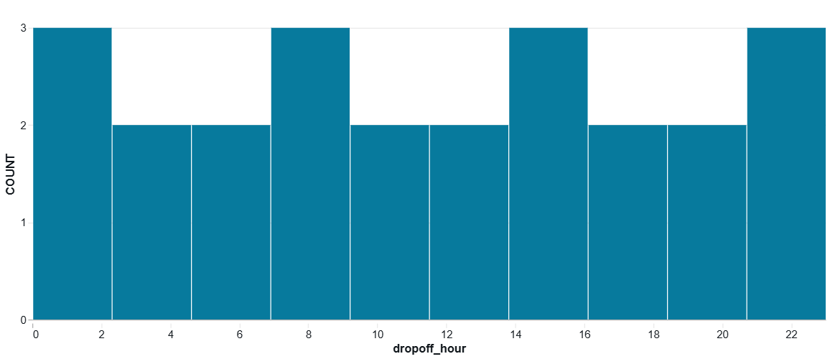

**Histogram**

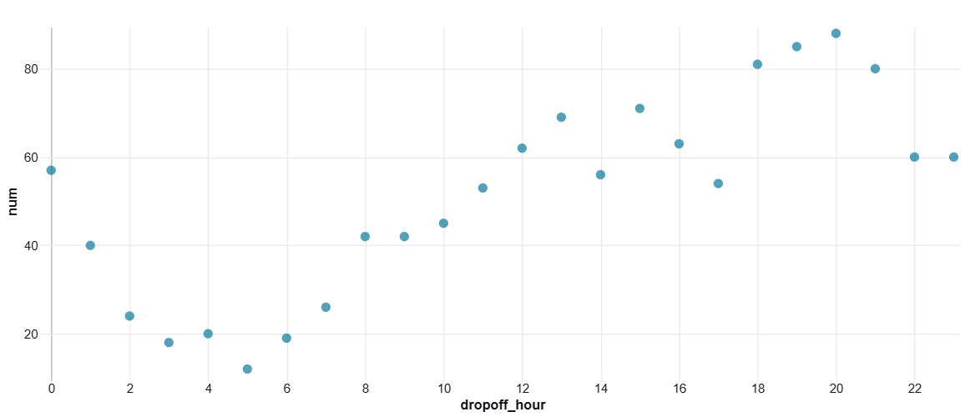

**Bubble**

**Submitted by**

Siva Balan T